**Project Planning Phase**

**Project Planning Template (Product Backlog, Sprint Planning, Stories, Story points)**

| Date | 27-10-2023 |
| --- | --- |
| Team ID |  |
| Project Name | Graphical Advantages: A tableau Exploration of Top Manga |
| Maximum Marks | 20 Marks |

**Product Backlog, Sprint Schedule, and Estimation (4 Marks)**

| **Sprint** | **Functional Requirement (Epic)** | **User Story Number** | **User Story / Task** | **Story Points** | **Priority** | **Team Members** |
| --- | --- | --- | --- | --- | --- | --- |
| Sprint-1 | Project setup & Infrastructure | USN-1 | Set up the development environment with the required tools and frameworks to start the graphical advantages project. | 1 | Medium | Jaswanth |
| Sprint-1 | Development Environment | USN-2 | collection of a diverse dataset encompassing manga sales data, which should include details such as sales figures, author information, genres, volume counts, and pricing information. | 2 | High | Samikshha |
| Sprint-2 | Data collection | USN-3 | proceed to gather the data and establish a connection between the dataset stored in MySQL and Tableau for visualization and analysis. | 2 | High | Kushagra |
| Sprint-2 | Data Preprocessing | USN-4 | perform data preprocessing on the collected dataset, which should involve filtering the necessary data, as well as addressing any null values or erroneous data. | 3 | High | Kushagra |
| Sprint-3 | Model Development | USN-5 | Generate graphs in Tableau using the user stories collected during the project design phase as the basis. | 4 | High | Samikshha |
| Sprint-3 | Model Deployment & Integration | USN-6 | Develop stories, dashboards, and reports in Tableau utilizing the graphs previously created as components. | 6 | Medium | Jaswanth |
| Sprint-4 | Observation & Inference | USN-7 | observations and inferences in Tableau based on the data and visualizations, utilizing the previously created graphs and insights. | 2 | High | Kushagra |

**Project Tracker, Velocity & Burndown Chart: (4 Marks)**

| **Sprint** | **Total Story Points** | **Duration** | **Sprint Start Date** | **Sprint End Date (Planned)** | **Story Points Completed (as on Planned End Date)** | **Sprint Release Date (Actual)** |
| --- | --- | --- | --- | --- | --- | --- |
| Sprint-1 | 3 | 3 Days | 25 Oct 2023 | 28 Oct 2023 | 3 | 28 Oct 2023 |
| Sprint-2 | 5 | 3 Days | 28 Oct 2023 | 31 Oct 2023 | 5 | 31 Oct 2023 |
| Sprint-3 | 10 | 4 Days | 31 Oct 2023 | 3 Nov 2023 | 10 | 3 Nov 2023 |
| Sprint-4 | 2 | 3 Days | 4 Nov 2023 | 7 Nov2023 | 2 | 6 Nov 2023 |
|  |  |  |  |  |  |  |
|  |  |  |  |  |  |  |
|  |  |  |  |  |  |  |

**Velocity:**

Imagine we have a 12-days sprint duration, and the velocity of the team is 20 (points per sprint). Let’s calculate the team’s average velocity (AV) per iteration unit (story points per day)

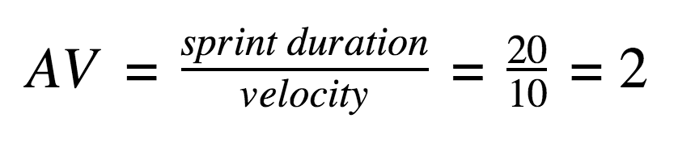

**AV= 12/20 = 0.6**

**Burndown Chart:**

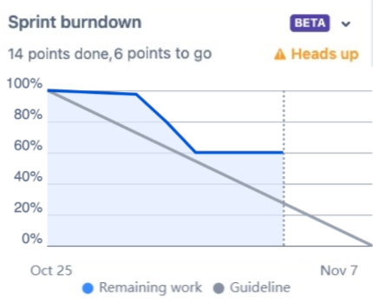

**Board section.**

We have completed sprint 1 and 2. So we can see the remaining tasks on board.

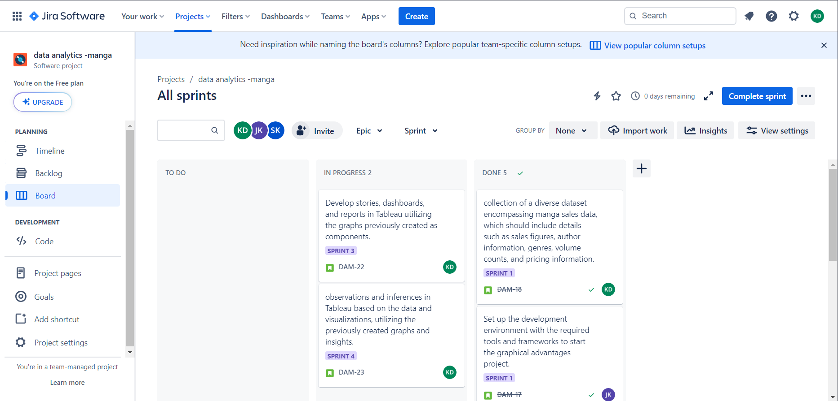

**Backlog section**

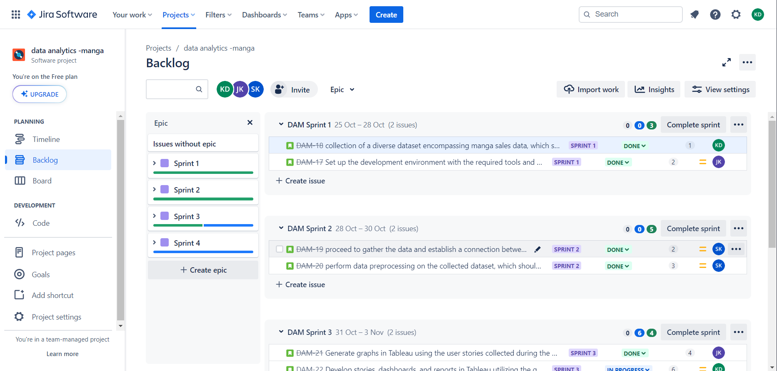

**Timeline**

